Why join the IB Diploma Program?
UNIVERSITY HIGH SCHOOL

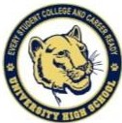
"Every Student College Ready"

IB is a unique educational program that:
- Provides students a well-rounded curriculum including the academic core, a second language, and the arts.
- Creates independent learners and strong writers
- Develops time management skills
- Cultivates international mindset
- Encourages critical thinking
- Provides multiple opportunities to earn college credits and scholarships
- Graduates strong communicators
- Qualifies students for advanced standing at colleges and universities in Florida and across the world

** Qualified students who earn the IB Diploma automatically earn 100% on the Florida Bright
Futures Scholarship requirements

How to apply?
Submit an electronic application at www.schoolchoice.ocps.net between November 1, 2020 and February 15, 2021

For more information contact: OCPS School Choice Services Magnet Office
Lea Bolves
Em ail: marylea.bolves@ocps.net Phone: 407 317 3484
CONTACT US

IB Coordinator
Tara Thorne
Tara.Thorne@ocps.net 407-482-8703

IB Administrator Thomas Ott thomas.ott@ocps.net
407-482-8701
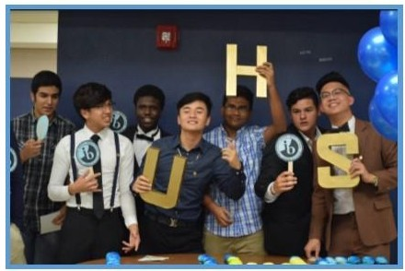

UNIVERSTIY HIGH SCHOOL
2450 Cougar Way
Orlando, FL 32817-3500

Phone : 407-482-8700
Website: https:// ti nyur l.com/ibweb

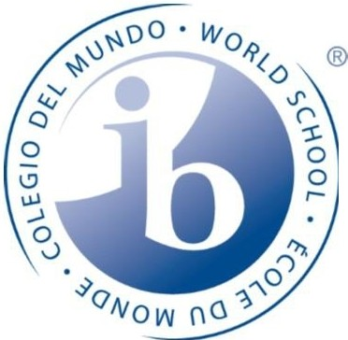
INTERNATIONAL BACCALAUREATE

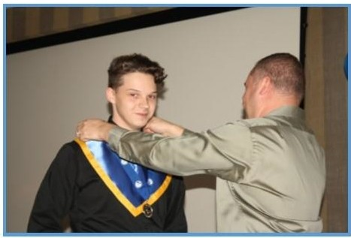

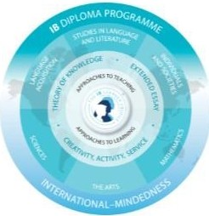
Frequently Asked Questions

Will my student have time for other activities? IB students participate in outside activities as much as, if no more than, other students. They play sports, join clubs, hold office, participate in band and chorus, perform in plays, serve on newspaper and year­ book staffs, attend prom and hang out with friends, just like everybody else. As a result, they learn to manage time well, a skill necessary for college success.
9th Grade Course Progression

Group 1:
FL Pre-lB English 1

Group 2:
FL Pre-lB Spanish or FL Pre-lB Latin

Group 3:
AP Human Geography

Group 4:
FL Pre-lB Biology
or FL Pre-lB Chemistry

Group 5:
Algebra 1
or Geometry or Algebra 2
or Pre-Calculus

UHS Electives (2 classes) Band, Chorus,
Orchestra, Theater,
ROTC, Bio. Science, Vet. Assistant, Comp. Science,
Informantion Technology, Journalism, Aerobics
10th Grade Course Progression

Group 1:
FL Pre-lB English 2

Group 2:
FL Pre-lB Spanish or FL Pre-IB Latin

Group 3:
AP World History

Group 4:
FL Pre-lB Chemistry or Science Class

Group 5:
Geometry and Algebra 2 or Algebra 2
or Pre-Calculus or AP Calculus AB
- • students must complete Algebra
2 by the end of loth grade.

UHS Electives (2 classes) Band, Chorus,
Orchestra, Theater,
ROTC, Bio. Science, Vet. Assistant, Comp. Science, Info. Technology,
Yearbook, Newspaper,

Are IB students isolated from the rest of the UHS student body?
IB students join other UHS students in the Pre-lB
electives, certain Advanced Placement (AP) classes, sports, and extracurricular activiti es. In their academic courses, IB students have the benefit of being with a group of similar motivated students who develop a close bond during their high school years.

If my student plans to attend a Florida state school, is there any benefit to having an IB Diploma?
Florida state schools actively seek IB students because of their proven performance and success in college. Earning the IB diploma entitles students to the Florida Bright Futures Scholarship. All Florida public universities grant college credit and/or advance standing for IB courses, saving up to a year of college expense and providing students the freedom to explore a more diverse course of study.

Is my IB student more likely to be accepted to schools outside of Florida?
Out- of –state colleges admit a higher percentage of IB applicants than they admit from their general pool. 1B students are nearly twice as likely to be accepted to schools such as Cornell, Duke, MIT, Dartmouth, Wellesley, and Johns Hopkins. Other institutions, including Tufts, Vanderbilt, and the U.S. military academies, admitted an even greater percentage of IB applicants, some as high as 95%. Clearly colleges recognize and reward the excellent preparation students receive in the IB program.

UNIVERSITY HIGH SCHOOL

"Every Student College Ready"

